Name Tags and Table Tents in Performance Matters
Use Quick Links on the SCSD homepage to access Performance Matters and log in using your SCSD username and password.
Locate the Courses I Teach channel, either on your home page or by clicking the Professional Learning tab.
Locate the course you want to manage, then click on the section title.
To print the section roster sign-in sheet for a section go to the section and select View Roster from the left action drop down menu.

From the buttons displayed on the Section Roster screen, click
Print name tags or table tents (with optional QR code for use with the mobile app).
From the buttons displayed on the Section Roster screen, click Name Tags
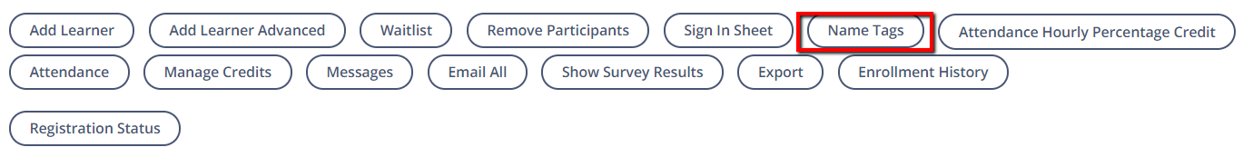
A new window will load.
To print name tags, click on the desired format. A PDF will open for you to save and/or print.
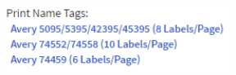

To print table tents, select whether you would like to include QR codes and click Print Table Tents. A PDF will open for you to save and/or print.

