Roster Management in Performance Matters
Use Quick Links on the SCSD homepage to access Performance Matters and log in using your SCSD username and password.
Locate the Courses I Teach channel, either on your home page or by clicking the Professional Learning tab.
.
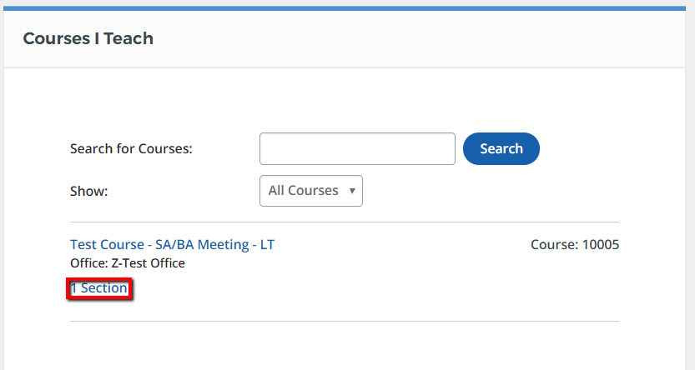
From the section action menu, select View Roster.
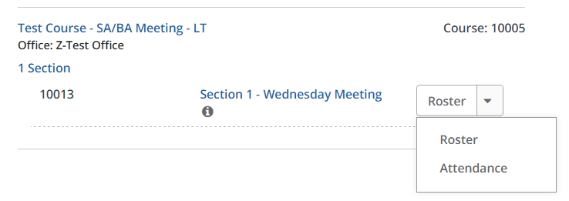
Course and section information will appear at the top of the section roster screen.
In the middle of the page, a set of buttons to access roster functions will display. (Buttons available will depend on course and section settings.)
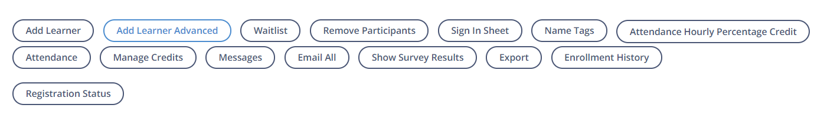
At the bottom of the page, the current roster is displayed.
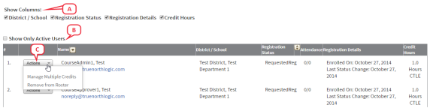
You can manually Add Learners or Remove Participants by using the buttons above the roster.

