Taking Attendance in Performance Matters
Use Quick Links on the SCSD homepage to access Performance Matters and log in using your SCSD username and password. Select Professional Learning from the top toolbar.
Find the course using the search feature or Courses I Teach, if you are the Instructor. Scroll down to the specific section at the bottom of the page.
To mark participants as attended for class times. Using the View Roster action menu for your section 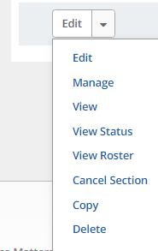
Use the buttons Add Learner or Remove Participants so that the roster matches your sign in sheet.
From the buttons displayed on the Section Roster screen, click Attendance.
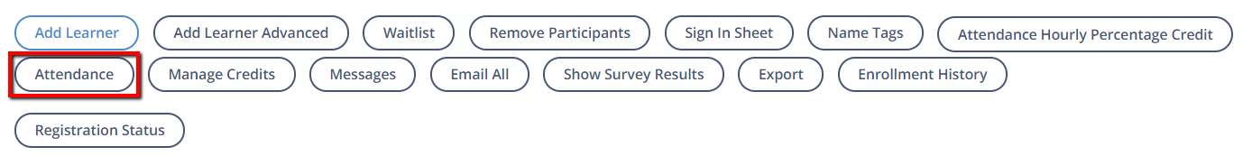
You can mark attendance in one of several ways. Choose A, B or C below.
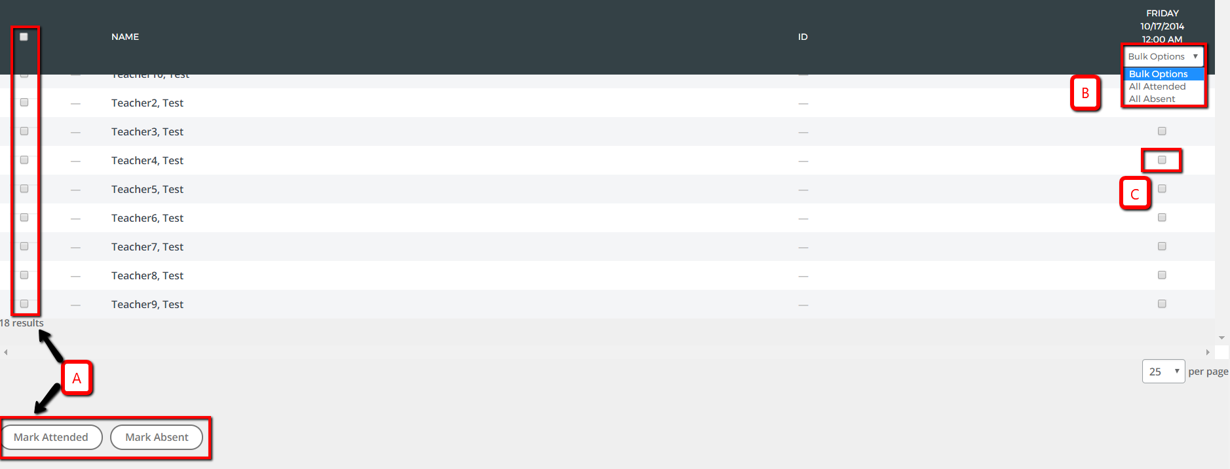
  - Select the checkbox for one or more participants, then click Mark Attended or Mark Absent to select the designated status for all selected participants for their entire row (all class times).
  - Select either All Attended or All Absent using the Bulk Options drop-down menu to select the designated status for all participants for one specific class time (one column).
  - Mark participant attendance individually by placing a check in the appropriate class checkbox.

Once attendance is complete, click Back at the top of the page.

