View Teacher Reaction Survey Results in Performance Matters
- Locate the Courses I Teach channel, either on your home page or by clicking the Professional Learning tab.
- Locate the course you want to manage, then click on the section title.
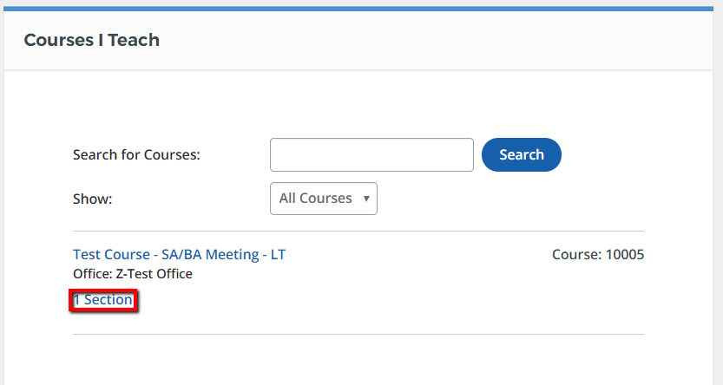
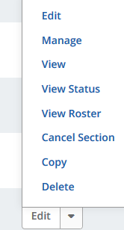
- From the section action menu, select View Roster

- From the buttons in the middle of the page select Show Survey Results. 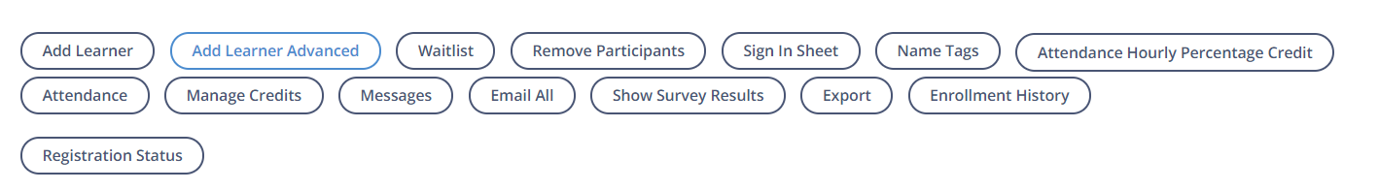
- Select Course Survey Results
