Continuing a Course Project in Performance Matters
- Use Quick Links on the SCSD homepage to access Performance Matters and log in using your SCSD username and password.
- Click Propose a Course in the tabs along the top of the screen.
- Click Course Projects in the Course Approval menu on the left.
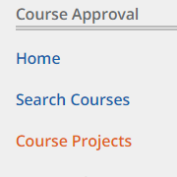
- A list of your course projects will appear. Click on the Actions menu next to the desired course project and select Edit Course.
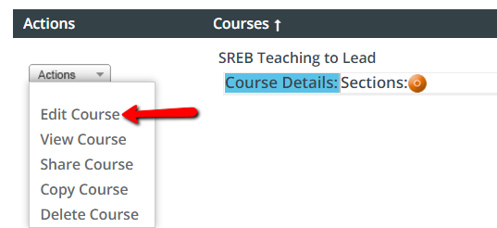
- Click on Edit Course again.
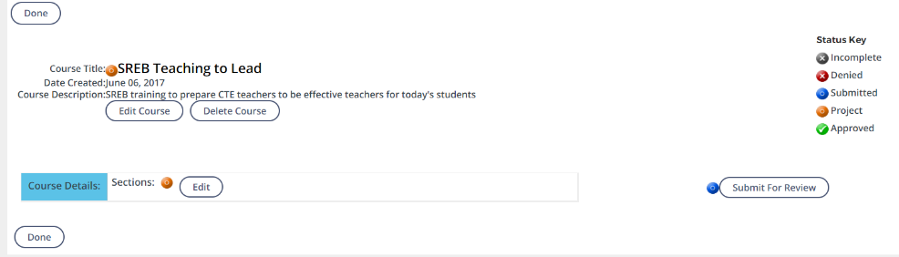
- Use the main action menu to select course information or settings for editing.
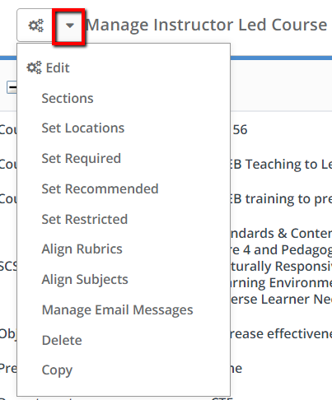
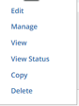
- Use the action menu for a specific section to edit that section.

Submit a Course for Review in Performance Matters
- When satisfied with all information for your course, click Submit for Review.
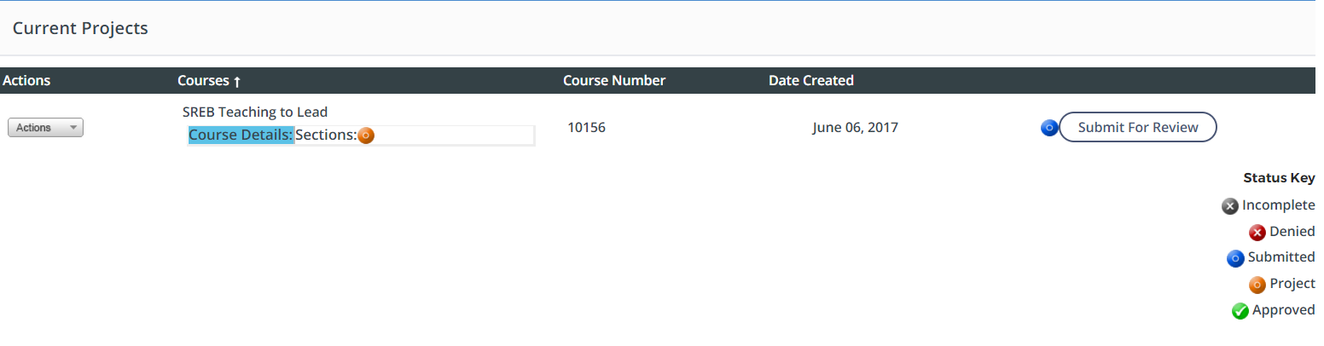
- Click OK when the pop-up appears.
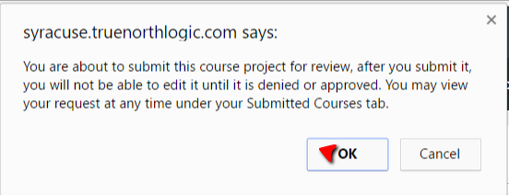
- Click OK again to close the confirmation.
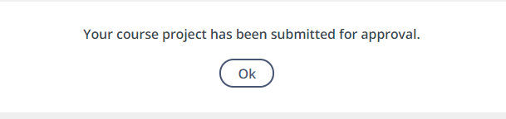
The course will no longer appear in Current Projects; it will now appear in Submitted Courses. The course cannot be edited while in review; you can only view or copy it.

Revise a Denied Course in Performance Matters
- Click Denied Courses in the Course Approval menu on the left.
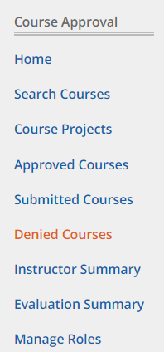
- Click on the Actions menu next to a denied course and select Edit Course.
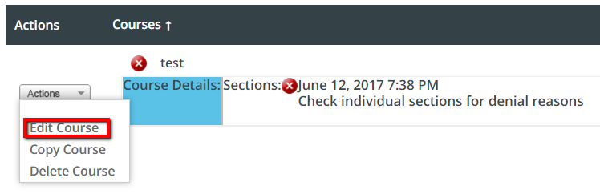

Edit Course Details and Settings
- If the course information or settings were denied, the Edit Course button will be enabled. Click to make necessary updates.
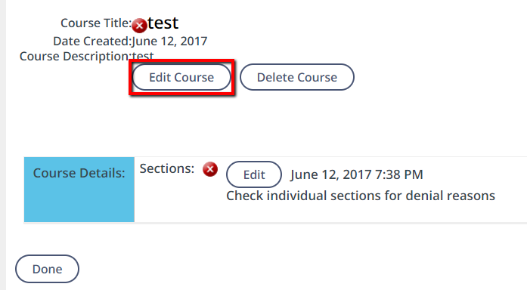
- Use the main action menu to select course information or settings for editing.
- Make the appropriate changes to the course and save them.
- When all necessary changes have been made to a course, click Done.

Edit Course Sections (Instructor-Led Course Types Only)
- If any of the course sections were denied, the Edit button will be enabled. Click to make necessary updates.
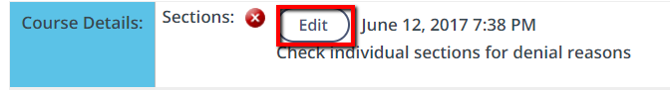
- On the Manage Sections screen, review the comments for a denied section, then click Edit from the action menu.
- Make the appropriate changes to the section and save them.
- When all necessary changes have been made to a section, click Done.
- Repeat for all sections that were denied. When complete, click Continue on the Manage Sections screen.

Resubmit the Course
- Once you have returned to the Manage Course screen, click Resubmit for Review to resubmit your course and sections. The Status key should show as a project.
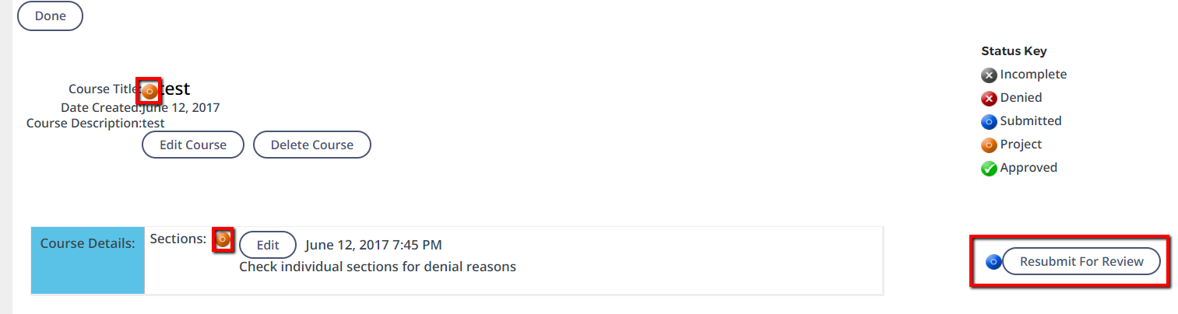
- Click OK when the confirmation pop-up appears.
- Click Ok again.
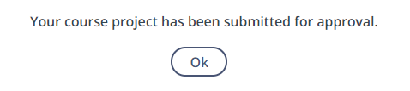
The course will no longer appear in Denied Courses; it will now appear in Submitted Courses.

