Create a Course for Approval
To create a new course and submit it for approval as a Course Requester, follow these steps.
Click Propose a Course in the tabs along the top of the screen.
The Course Approval screen is displayed and includes the following features.
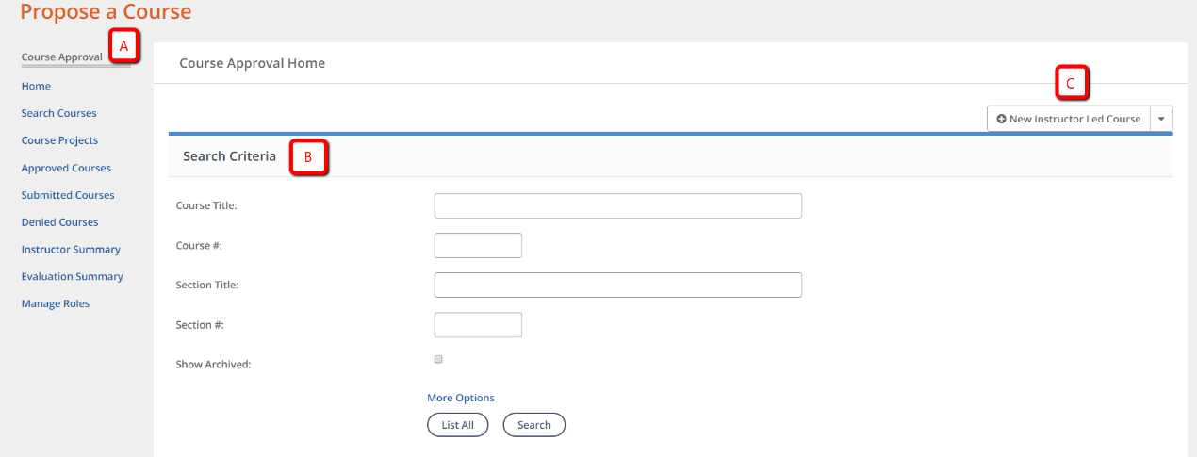

On the right side of the Course Approval screen, click +New Instructor Led Course.
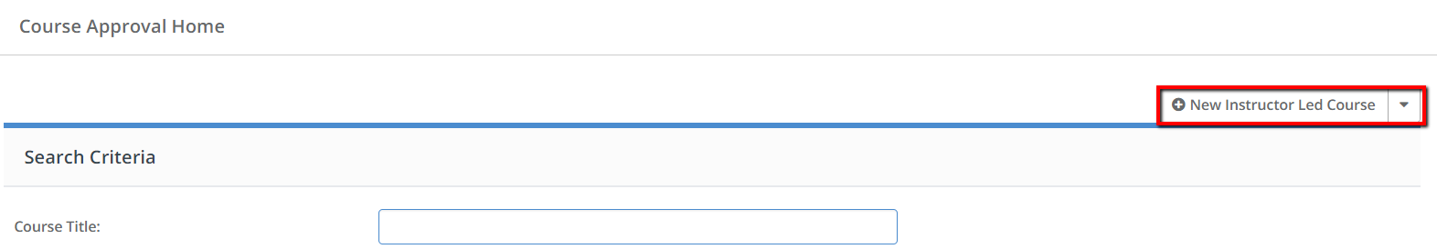

Complete Course Details
Complete the course details, noting that required fields are identified by an asterisk (*). Fields that are indicated by an asterisk must be completed before the course can be saved.
Particular fields to note include the following.
  - Course Title - Enter a clear, descriptive, and distinct name for the course.
  - Department - Select the office that will own this course to ensure the correct Course Approver will review the course, and the correct Office Administrator will be able to manage the course.
  - Credit Types or Possible Credit - Define what type(s) and how much credit can be awarded to the Course Participant upon completion of the course or section.
  - SCSD PD Strands – one or multiple strands can be selected.
  - Course Survey - This field defaults to SCSD Course Survey, however, the Principal Survey and VPI Survey are additional choices. The one Month Follow-up Survey should be elected when creating the section only.
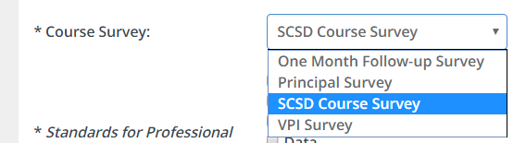

  - Standards for Professional Learning – One or multiple standards can be selected.
  - Archived - This option should NEVER be selected during course creation.
Once the form is complete, click Create Instructor Led Course at the bottom of the page to save it.
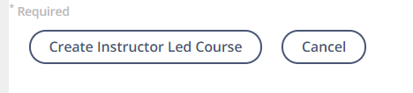
CAUTION
You have 60 minutes from the time you access this page until you click the Create... button before the page is reset, and any information entered is lost. For longer forms, we recommend completing the required fields first, save the course, then continue filling out the optional fields.

Subjects
To align your course to a specific subject, level, or support service, click on Align Subjects.
Select the areas to which you wish to align the course.
Once finished, click Save.
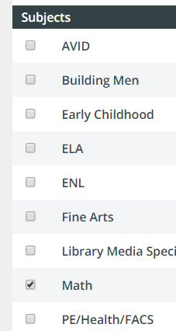 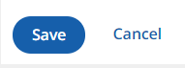
Each course created needs a least one section with the specific dates and times. If you wish to create a section now, go to Add new section at the bottom of the page or you can come back to this course later in your Course Projects.

