Registering for a Course
Once you’ve created a course and want participants to register they can search your course by title or you can send them your course number. After they have signed in and located the course they will follow the instructions below.
- Click a course or section title to view additional details. (Click the i icon for a quick preview of section details.)
- 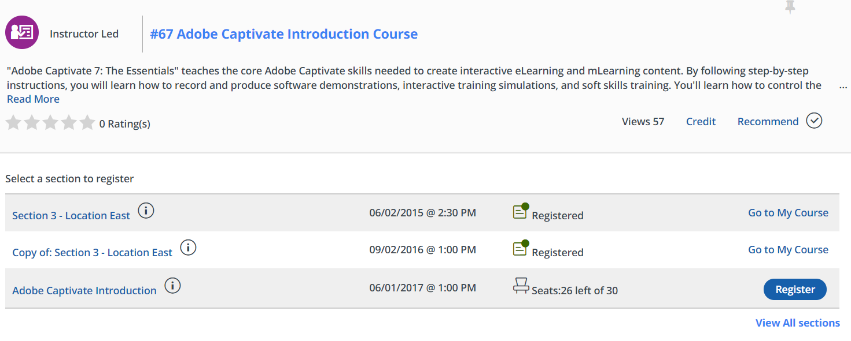

- If there are multiple sections available for a course, the first three sections will be visible below the course title and description. Click on the View All Sections to view all options.

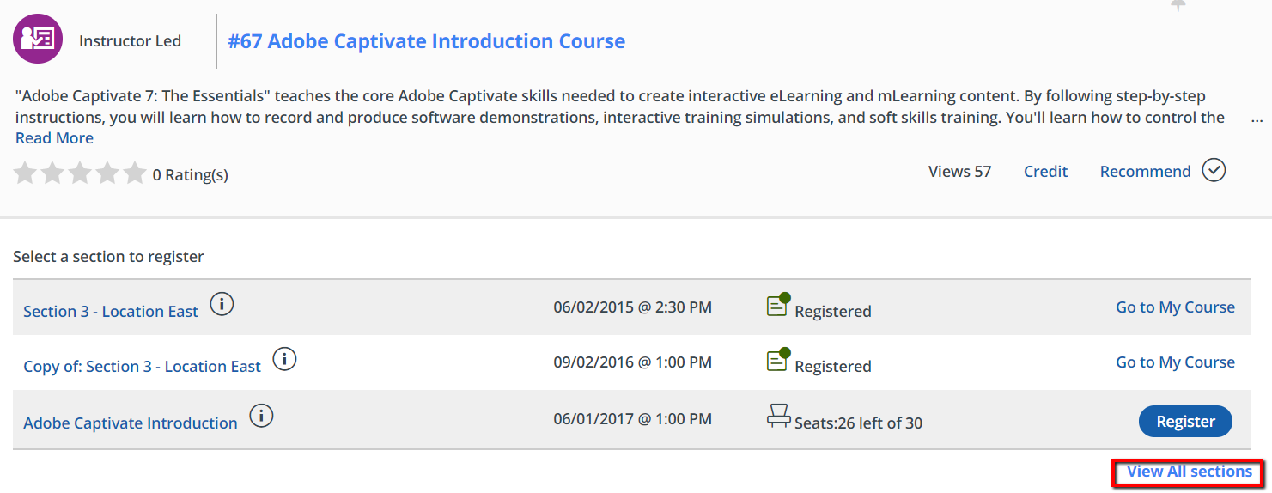

- Click Register for the desired section.
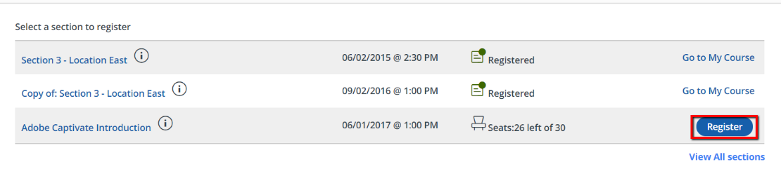
- Confirm the section information, then select Next to continue registration.
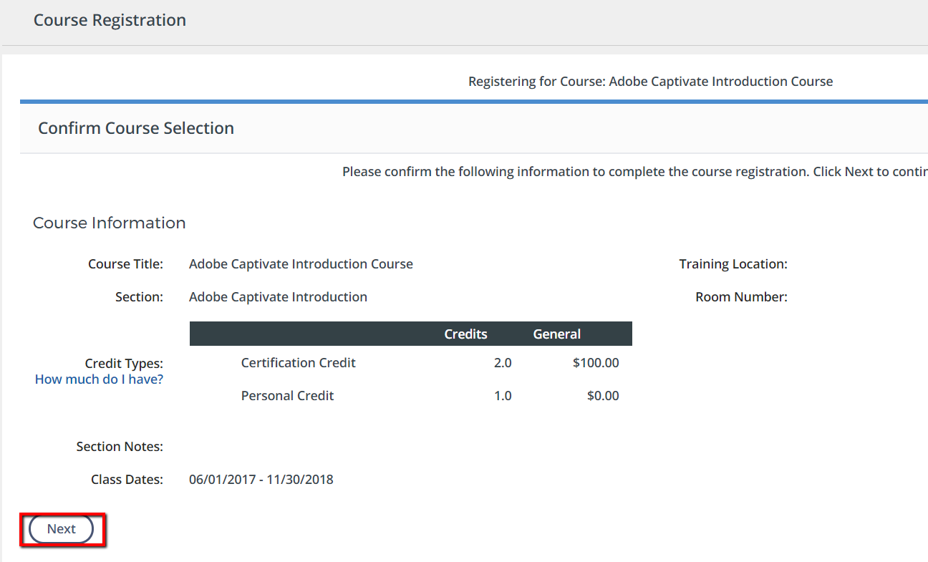
- Once registration is successful, the confirmation screen will appear.
