Roster Report in Performance Matters
Each building site administrator (principal) can run a report on their staff participation in professional development. The process for this has changed slightly and the steps are outlined in this document. Only the principals, as the site administrator have access to this report. They can share the data with their administrative team once the report is run. The report is specific to each building (site).
Please contact the PD department with any questions.
In Performance Matters - Administration - Select Ad hoc Reporting on the left menu - Scroll down to Roster and select Arrow all the way on the right.
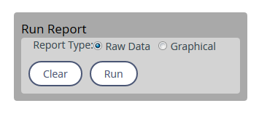
Click the in front of 18/19 PD Roster Report. 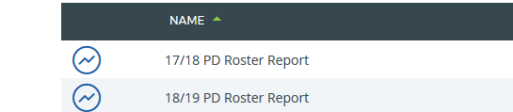
Then choose Run from the next screen.

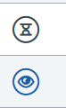
A list of most recent reports will open. The hourglass symbol means your report is processing. You will receive an email when your report is ready. The eye symbol means your report is view-able now.
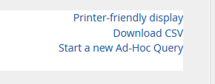
Click the eye to open your report to view.

Select Download CSV in the top right and then save the report as an Excel workbook to sort or pivot the data.

