Adding a Section in Performance Matters
Use Quick Links on the SCSD homepage to access Performance Matters and log in using your SCSD username and password.
There are several options when adding a section, please choose from A, B or C below.
- If this is a course you have not added any sections for: Select Propose a Course from the top toolbar then select Course Projects along the left side to find the course you are working on.
OR B. If you are adding a section to an approved course select Propose a Course from the top toolbar and then choose Manage from the action menu in front of the Approved Courses tab to find the course you are working on then scroll to the bottom of the screen and click on New Section.
OR C. If you just created the course and are still on the course page, scroll to the bottom of the screen and click on New Section.
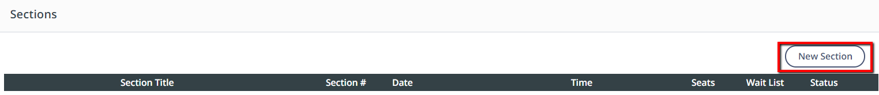
Complete the form, noting that required fields are identified with an asterisk (*).
  - Title - Enter a clear, descriptive, and distinct name for the section.
  - Address - Complete the section meeting location fields to enable a map link for the Course Participant.
  - Attendance - Select whether the section attendance will be taken once or twice a day. This determines the format of the sign-in sheet. For all day sessions attendance is taken twice a day.
  - Minimum Number of Participants - Define the number of participants required to conduct the section.
  - Maximum Number of Participants - Define the maximum number of participants that the section/room can accommodate. Registration for this section becomes unavailable once this number is reached.
  - Allow Waitlist - Select to allow a Course Participant to sign up for the waitlist of a filled section. If a registered Course Participant withdraws from the section, a waitlist participant will automatically be moved to that spot.
  - Start Date - Select the first meeting date for this section. This will determine the default first date when defining specific class times.
  - End Date - Select the last meeting date for this section. This will determine the default end date when defining recurring class times.
  - End of Registration Date - Select the last date a Course Participant can register for this section, this should be at least one day after the session start to allow participants to register the day of the session.
  - Waitlist Cutoff Date - Select the last date a Course Participant can sign up for the waitlist.
  - Classtime Default (Start Time) - Select the beginning meeting time for this section. This will determine the default start time when adding specific class times.
  - Classtime Default (End Time) - Select the ending meeting time for this section. This will determine the default end time when adding specific class times.
  - Follow-up Survey Date – select the date the Follow-up Survey should be sent to section participants. This should generally be one month after the class date.
  - Release Section Now - Select to make the section available in the catalog immediately. (When approval is required, the section will not be available until approval by the Course Approver.) Or Release Section At - Select the date and time to make the section available in the catalog. (When approval is required, the section will not be available until approval by the Course Approver.)

Click Save to create the new section.
You are not quite done yet, the steps below are necessary to complete your section.
You will see a summary of your section. Scroll to the bottom to access buttons for additional section settings.
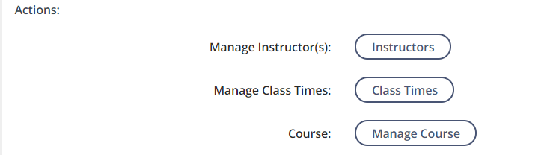

Manage Instructors
To assign an in-district instructor to your section, click Instructors.
Search for the instructor by first or last name. Then click Find User. This must be an in-district person.
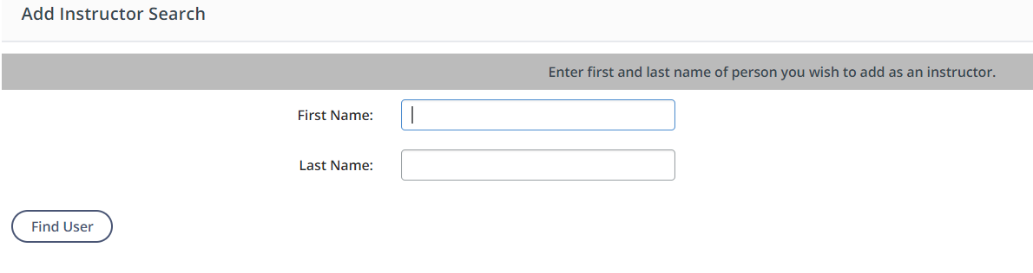
Once you see the name of the instructor, check the applicable box, then click Add User(s).
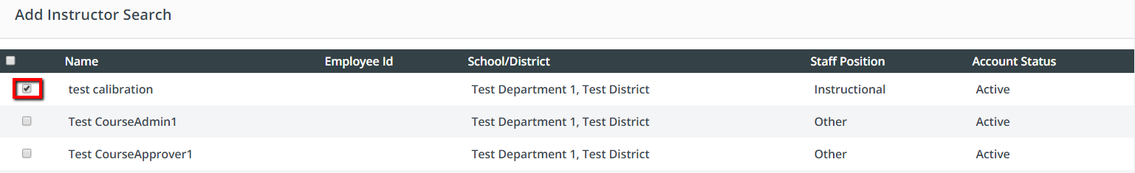
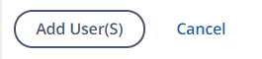
Click Done.

Manage Class Times NOTE -Class times are required to create the sign-­in sheet and populate the attendance page.
To set specific meeting times for your section, scroll to the bottom and click Class Times. 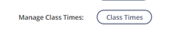
To set a new class time, click Add New Day.
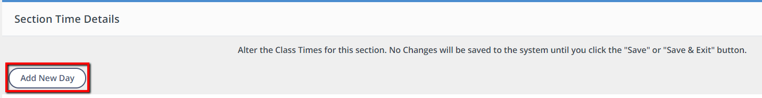
The date will default to the Start Date you entered on the section form. Adjust as needed.
The times will default to the Start Time and End Time entered on the section form. Adjust as needed.
To set another class time, repeat steps 2-4.
When finished, click Save & Exit.
If you want to add another section, click Manage Course to return to the course editing screen. Repeat these steps until all sections have been added.
If you have finished adding sections and the course definition is complete, click Done.
Don’t forget to submit your course and/or sections for approval.

