Manage Credits and Course Completion in Performance Matters
Use Quick Links on the SCSD homepage to access Performance Matters and log in using your SCSD username and password. Select Professional Learning from the top toolbar. Find the course using the search feature or Courses I Teach, if you are the Instructor. Scroll down to the specific section at the bottom of the page.
Adjust credit for multiple users. From the buttons displayed on the View Roster screen, click Manage Credits.
Bulk Credits
The credits (hours) for all participants can be awarded at once using Bulk Credits at the top of the page. Enter the desired credit amount for the desired credit type and click Update Learners.
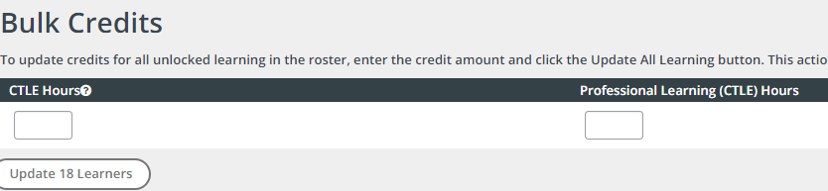

Individual Credits
You may adjust individual participant credits within the table.
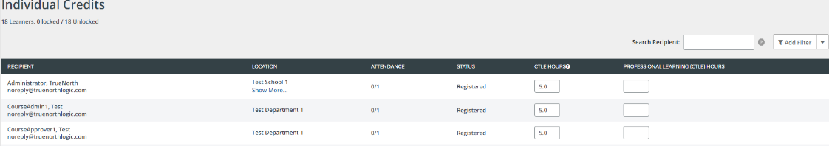
Once finished adjusting credits, click Done at the bottom of the screen.

Roster Status
From the buttons displayed on the Section Roster screen, click Registration Status. The editable fields on the roster list below will change.
If you desire to change roster status of all participants at once, click on the drop-­down menu and make the appropriate selection. Status of all participants will change in the list below. Select Completed
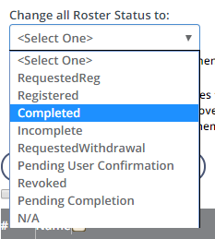
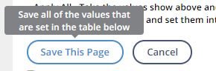
When finished, click Save This Page to save all selections.

