Sign-In Sheets in Performance Matters
Use Quick Links on the SCSD homepage to access Performance Matters and log in using your SCSD username and password.
Select Professional Learning from the top toolbar.
Find the course using the search feature or Courses I Teach, if you are the Instructor. Scroll down to the specific section at the bottom of the page.
Print the section roster sign-in sheet for a section go to the section and select View Roster from the left action drop down menu.

From the buttons displayed on the Section Roster screen, click Sign In Sheet.

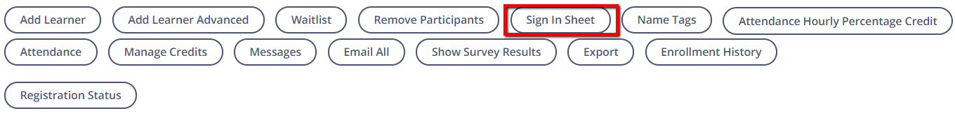
If the section has multiple class times, select the appropriate date by clicking the arrow until the correct date is displayed.
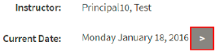
A new window will load.
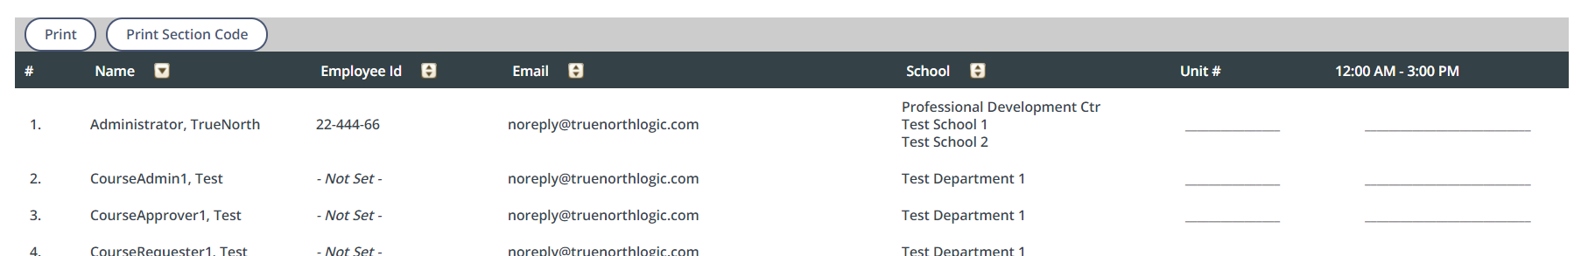
Select Print.

