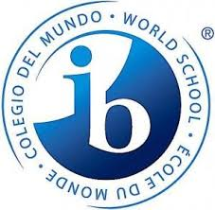
International Baccalaureate
CAS ACTIVITY COMPLETION FORM

Corcoran High School Syracuse, New York

Session __________________________________ School Number 1519
Candidate Name (print) __________________________________________________________
Candidate Number __________________________________________________________
Name of Activity or Project _______________________________________________________
Circle One: Creativity Activity Service Project
Hours completed ______________________________
Dates of Experience _____________________________________________________________
Candidates Signature ____________________________________________________________

To be completed by the experience leader
Please briefly comment on the following for the candidate:
Punctuality and Attendance _______________________________________________________
Effort and Commitment __________________________________________________________
Satisfactorily Completed? ________________________________________________________
Signature _____________________________________________________________________

Return this form to CAS Coordinator- Ms. Files

