Attachment #2
New York State Program Application Packet for Universal Pre-Kindergarten in High Need School Districts (UPK)

Syracuse City School District – New York State Funded Pre-Kindergarten Programs For the
2022-2023 School Year
New York State Program Application Packet
Universal Pre-Kindergarten in High Need School Districts (UPK)

Agency/Organization Name:

Physical location/address of proposed classroom(s)*:

*please attach a separate page for each additional physical location

Number of proposed full day 3 Year Old UPK seats at this location
Number of proposed half day 3 Year Old UPK seats at this location
Number of proposed full day 4 Year Old UPK seats at this location
Number of proposed half day 4 Year Old UPK seats at this location
Hours of full day program operation
Hours of half day program operation
Number of NYS certified teachers for this location
Number of teaching assistant/aides for this location

What is the average classroom square footage per child at this
location?

Is there an indoor gross motor space available at this location? | ☐Yes ☐No
- If yes, please describe space and available equipment:
- If no, please describe plans to meet programmatic gross motor requirements:
Is there an outdoor gross motor space available at this location? | ☐Yes ☐No
- If yes, please describe space and available equipment:
- If no, please describe plans to meet programmatic gross motor requirements:

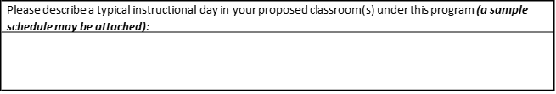

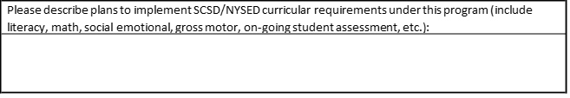

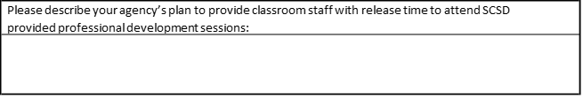

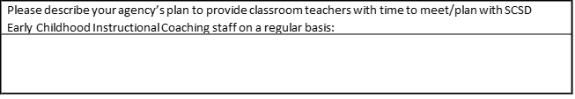

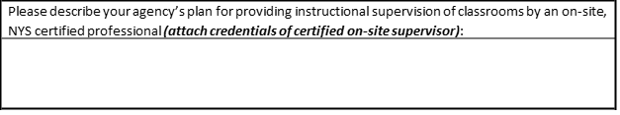

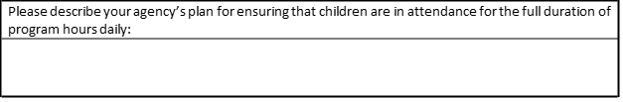

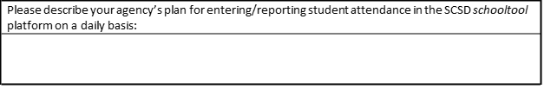

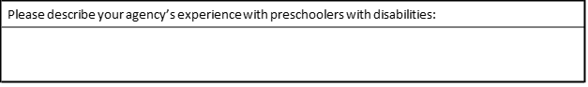

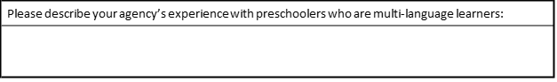

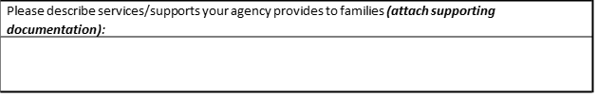
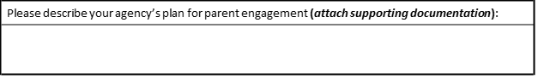

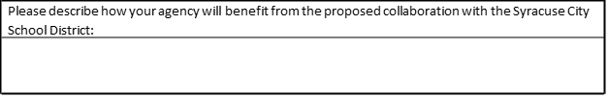

Program Director Signature: Date:

Chief Executive Officer Signature: Date:

Attachment #3
New York State Program Application Packet for Statewide Universal Full Day Pre- Kindergarten Program (SUFDPK)

Syracuse City School District – New York State Funded Pre-Kindergarten Programs For the 2022-2023 School Year
New York State Program Application Packet
Statewide Universal Full Day Pre-Kindergarten Program (SUFDPK)

Agency/Organization Name:

Physical location/address of proposed classroom(s)*:

*please attach a separate page for each additional physical location

Number of proposed full day 3 Year Old SUFDPK seats at this location
Number of proposed half day 3 Year Old SUFDPK seats at this location
Number of proposed full day 4 Year Old SUFDPK seats at this location
Number of proposed half day 4 Year Old SUFDPK seats at this location
Hours of full day program operation
Hours of half day program operation
Number of NYS certified teachers for this location
Number of teaching assistant/aides for this location

What is the average classroom square footage per child at this location?

Is there an indoor gross motor space available at this location? | - Yes ☐No
- If yes, please describe space and available equipment:
- If no, please describe plans to meet programmatic gross motor requirements:
Is there an outdoor gross motor space available at this location? | - Yes ☐No
- If yes, please describe space and available equipment:
- If no, please describe plans to meet programmatic gross motor requirements:

Please describe a typical instructional day in your proposed classroom(s) under this program (a sample schedule may be attached):

Please describe plans to implement SCSD/NYSED curricular requirements under this program (include literacy, math, social emotional, gross motor, on-going student assessment, etc.):

Please describe your agency’s plan to provide classroom staff with release time to attend SCSD provided professional development sessions:

Please describe your agency’s plan to provide classroom teachers with time to meet/plan with SCSD Early Childhood Instructional Coaching staff on a regular basis:

Please describe your agency’s plan for providing instructional supervision of classrooms by an on-site, NYS certified professional (attach credentials of certified on-site supervisor):

Please describe your agency’s plan for ensuring that children are in attendance for the full duration of program hours daily:

Please describe your agency’s plan for entering/reporting student attendance in the SCSD schooltool
platform on a daily basis:
Please describe your agency’s experience with preschoolers with disabilities:
Please describe your agency’s experience with preschoolers who are multi-language learners:

Please describe services/supports your agency provides to families (attach supporting documentation):

Please describe your agency’s plan for parent engagement (attach supporting documentation):

Please describe how your agency will benefit from the proposed collaboration with the Syracuse City School District:

Program Director Signature: Date:

Chief Executive Officer Signature: Date:

Attachment #4

Proposal Fee Schedule – Agency Budget Form

***** NOTES TO AGENCY BUDGET FORM *****
- The fee proposal is an all-inclusive maximum price per student for the services proposed.

- This per-student rate assumes that the District receives the full funding allocation for these programs from New York State.

- This per-student rate assumes the agency will operate for a minimum of 180 instructional days for students.

- Fees are paid based on student attendance at the program. If a student does not attend the program, the Agency will not receive payment for that student.

Syracuse City School District – New York State Funded Pre-Kindergarten Programs
for the 2022-2023 School Year
Agency Budget Form

Please complete a separate form for each program you are applying to:
(check ONE) ☐UPK ☐SUFDPK
(# Students X $ Rate = $ Total)
*RATES ASSUME MINIMUM 180 INSTRUCTION DAYS & FULL FUNDING AMOUNT FROM NYS*
UPK Budget
Program | # |  | $ Rate |  | $ Total
Proposed 3 Year Old FD Seats |  | X | $6,500 | =
Proposed 3 Year Old HD Seats |  | X | $4,500 | =
Proposed 4 Year Old FD Seats |  | X | $5,655 | =
Proposed 4 Year Old HD Seats |  | X | $3,500 | =

SUFDPK Budget
Program | # |  | $ Rate |  | $ Total
Conversion |  | X | $3,750 | =
New |  | X | $8,000 | =
# of Statewide seats should reflect 2019-2020 School Year
Total Proposed Budget Request = $
Please provide a narrative description of reasonable, appropriate and necessary expenditures:

Profession salaries detail:

Total dollar amount for professional salaries = $

Supplies and materials detail:

Total dollar amount for supplies & materials = $

Purchases services detail:

Total dollar amount for purchased services = $

Program Director Signature: Date:

Chief Executive Officer Signature: Date:

