Sun. | Mon. | Tues. | Wed. | Thurs. | Fri. | Sat.
 |  |  |  |  | 1 | 2
3 | 4 | 5 | 6  Cocoa & Crafts 6:30-7:30 | 7 | 8  ½ day dismiss @ 11:30 | 9
10 | 11 | 12 | 13 | 14  4th/5th holiday concert 7pm | 15  4th/5th holiday concert  9:30 am | 16
17 | 18 | 19  PTO Meeting 6-7 | 20 | 21 | 22 | 23
24/31 | 25  No School | 26  No School | 27  No School | 28  No School | 29  No School | 30
The Friends of
Syracuse Latin PTO
December 2017 Newsletter

Find us on Facebook

Syracuse Latin School PTO
(School events, community information will be shown on the PTO page. It’s a great avenue to have any questions answered)

The Syracuse Latin School
(The school will post staff/student kudos and pictures on this page. Members cannot post here)

December Important Dates

PTO Board Members for the 2017-2018 School Year

Brea Allers- President Margaret Chajka- Treasurer Ginny Russell- Fundraising Chair
Kerry Zubrzycki- Vice President Kristin Mecum- Secretary Katie Cramer/Meredith Austin-Communications
Faculty Reps- Mr. Chirinos, Ms. Frost, and Ms. Weigand

!!Join Us!!

Cocoa and Crafts

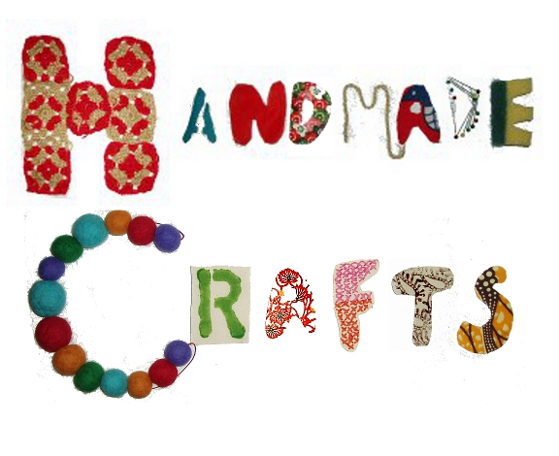

PTO presents our first annual Cocoa & Craft Night! Come support our Latin scholars as they spread joy to the residents at Loretto Health & Rehabilitation Center on Wednesday the 6th from 6:30 - 7:30 in the cafeteria. This is a great family event for everyone! Cocoa will be hot and the room filled with holiday cheer! Hope to see you there!

Happy Holidays Syracuse Latin Families!

Despite there only being 3 weeks of school in the month of December there is a lot going on. The PTO is holding our first annual cocoa and crafts night, the student holiday shoppes, and the 4th/5th grade holiday chorus concert.
The PTO is looking for volunteers to help out at the gift wrap station during the Holiday Shoppes. The Holiday Shoppes will be held December 13th-19th during the school day. If you are interested in volunteering please go to our signup genius link on the Facebook page.

Reminder: PTO meeting Tuesday, December 19th from 6-7 in the cafeteria. Childcare will be provided.

