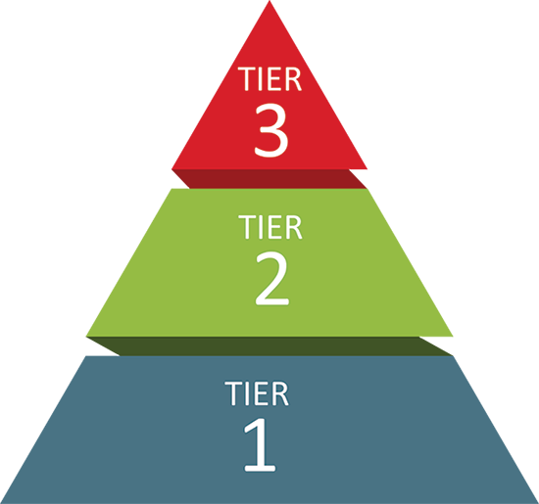
Brighton Academy
Tier 1
Universal Supports
Schoolwide and classroom practices that promote the development and practice of pro-social behaviors, self-discipline, habits of learning, and healthy well-being.
Rickey Gregory
Dignity Act Coordinator
Alexis Jackson
Dignity Act Coordinator
Flaynesha Rashad-Freeman
Student Support Center Staff
Jacob Quilty-Koval/Monica Shaw
School Counselors
Sanar Bolds
Family Program Aide, Office of Family Engagement
Tier 2
Targeted Supports
Coordinated supports that match students’ social, emotional, and mental health needs to address the root cause of an issue.
James Chaplin
PromiseZone Specialist
Agnes Sageer
Special Education Liaison
Alexis Jackson
Social Worker
Mary Kelly
Social Work Assistant
Krystal Coleman
Section 504 Administrator
Krystal Coleman
Section 504 Liaison
Tier 3
Intensive Supports
Intensive, specialized support.
Amanda Brownell
Mental Health Clinician, Liberty Resources
Michelle Haskins
Family Support for Student Success, School/Family
Jackie Guglielmo
Access School Liaison
Nicole McMillan
School Psychologist
Aziza Mohamed/Aduke Watts-Branch
Youth Development Specialists (Contact)
Rashonda Barnett
HOPE Specialist
Aleza Shanahan
Hillside Youth Advocates
Ruby Blount/Jordan Washington/Kheyaire McMullen
Street Addiction
Unique Works
Peaceful Schools
TIERED SYSTEM OF SUPPORTS

