**Canvas Online Course Guide**

SCSD students will have the opportunity to participate in online coursework in the case of an extended emergency school closure. The following is a guide to help you get started and work through the coursework in Canvas.

**Logging into Canvas**

1. Use **Chrome**! Canvas does not work in Internet Explorer.
2. Open the SCSD Homepage, navigate to Library Links, and open CLEVER.
3. Log into CLEVER using your SCSD computer username and password.
4. Click on the Canvas App.

**Accepting Course Invitations**

1. After logging into Canvas, look for course invites at the top of your **Dashboard** page.
2. Click the green **Accept** button for each to add courses to your dashboard.

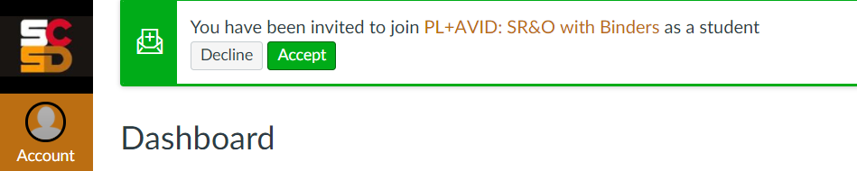

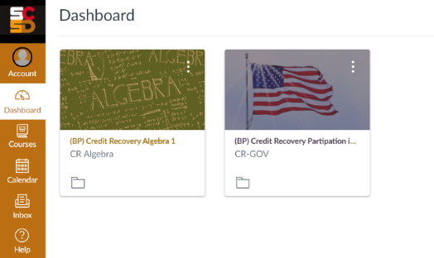**Accessing Courses**

1. Whenever you want to access a course, log into Canvas.
2. Find the tile for the course you would like to access, and **click on the course title**. If you do not see a course tile, click **Courses** on the far left navigation, then **All Courses**. Fill the star next to the course title to add to dashboard.
3. From the course home page, click on the word **Modules** on the left sidebar to access the course activity outline.

**Understanding the Course Home Page**

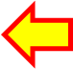Once you open a course from the Dashboard, you will land on the course **Home** page. This page includes:

2

1. Links to the course **Module** page, your **Grades**, and **Office** 365.
2. Directions and an introduction to the course.
3. Notifications about upcoming assignments and teacher feedback. Click on each notification to open!

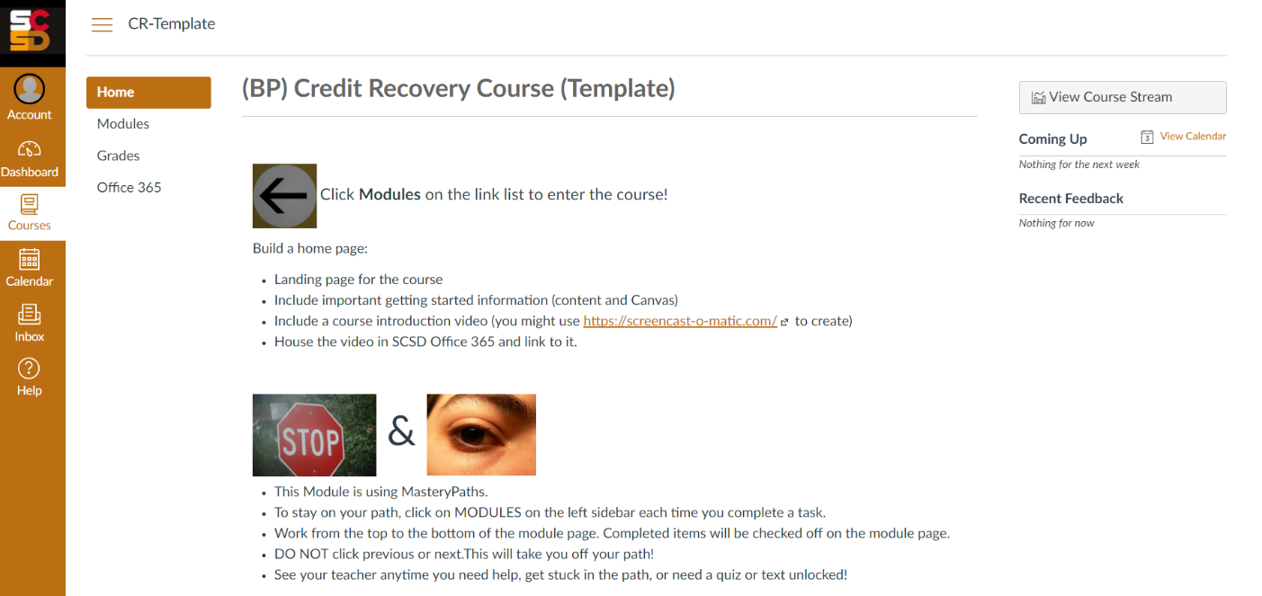

3

1



1. The far left (under the SCSD logo) is the global navigation bar for Canvas, including **Account**, where you can edit your notifications. To the right of the global navigation bar is the course specific link list.
2. All activities to be completed are on the **Module** page of the course. Please note:

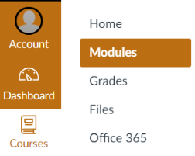****

5

4

Students can **always click on the Module page** to view & complete all available activities.

1. Tasks will open in order from top to bottom as you successfully complete them from the first unit to the last.
2. You should see empty circles next to tasks that need to be completed.
3. Green checks replace the empty circles once the task is complete.
4. Under each task title is information about the task requirement and deadline (if added by teacher).

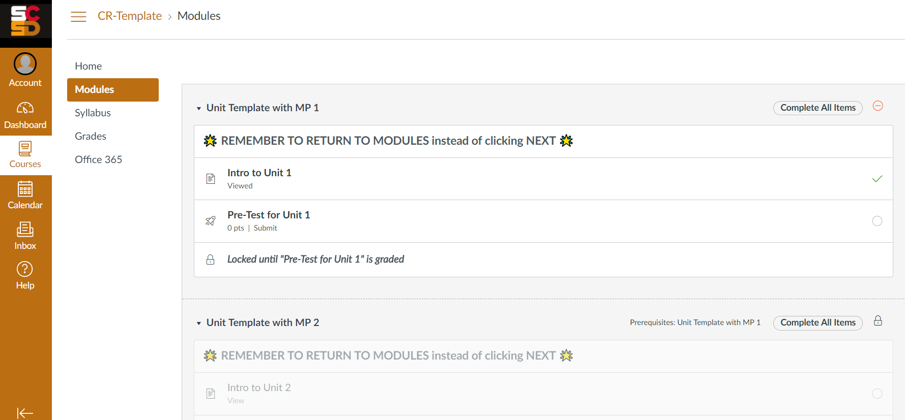





9

8



7



6

**Navigating Canvas**

* Once you open a course via the course tile on your dashboard, click **Modules** on the left sidebar.
* **Work from top to bottom** in the course modules. Under the task title, you will see a completion requirement.
* Click on each task title to open it. Then, read and follow the directions provided within the task to complete it.
* Short & long answer responses should be typed & saved in a Word doc before pasting or submitting in Canvas.
* Return to **Modules** or **Grades** after completing a task to view progress.
* You will see a green check next to the tasks you have completed and an empty circle next to those not yet done.
* Return to your **Dashboard** when you are ready to access a different course!

|  |  |  |  |
| --- | --- | --- | --- |
| Each task title on the **Module** page has an icon to tell you what type of activity it is: | | | |
|  |  |  |  |
| Quiz | Discussion Forum | Content Page | Assignment |

Canvas works on mobile phones. Use phone browser and follow the same access directions outlined above.

**Completing Assignments**

|  |  |
| --- | --- |
| **Participating in Discussion Forums** | **Submitting Assignments** |
| Discussions allow you to share ideas with classmates online in a safe space. See below for how to post your ideas and reply to your classmates. | Most courses included a “diving deeper” assignment you must complete & submit. Files can be uploaded from your computer or Office 365. |
| Make sure to click **Post** **Reply** before closing the window! |  |
| **Taking a Quiz** | **Adjusting Notification Preferences** |
| Quizzes are used to pretest out of basic content in most courses. They are also commonly used as a unit test for each module or unit of study. | You can add your mobile phone number to be notified of course announcements via text. You can also adjust your notification settings for many features – less or more! |
| Click the button to take the quiz.  Make sure to **submit** when done! | To adjust, open **Account > Notifications**, and follow these directions: [bit.ly/notifycanvas](https://bit.ly/notifycanvas). |
| Read quiz directions carefully. You may have one or more attempts to successully complete the quiz based on quiz settings. Let your teacher know if you get locked out of moving onto the next course task. | **Notification Options**:  Check = immediate  Clock = daily summary  Calendar = weekly summary  X = never notified |
| **For more detailed directions and support, explore the Canvas Help Guides.**  **Click the question mark icon on the Global Navigation Links.** | |

**Viewing Grades & Feedback**

Grades and feedback can be opened by clicking on the notifications listed on the **Dashboard** or **Home** pages.

A number next to the **Grades** link in the course indicates new grades or feedback. To access:

1. Click **Grades** on the course link list to see all your grades and feedback in one place.
2. Click on the speech bubbles to the right of an assignment title to open teacher comments.
3. Review your teacher’s comments.
4. 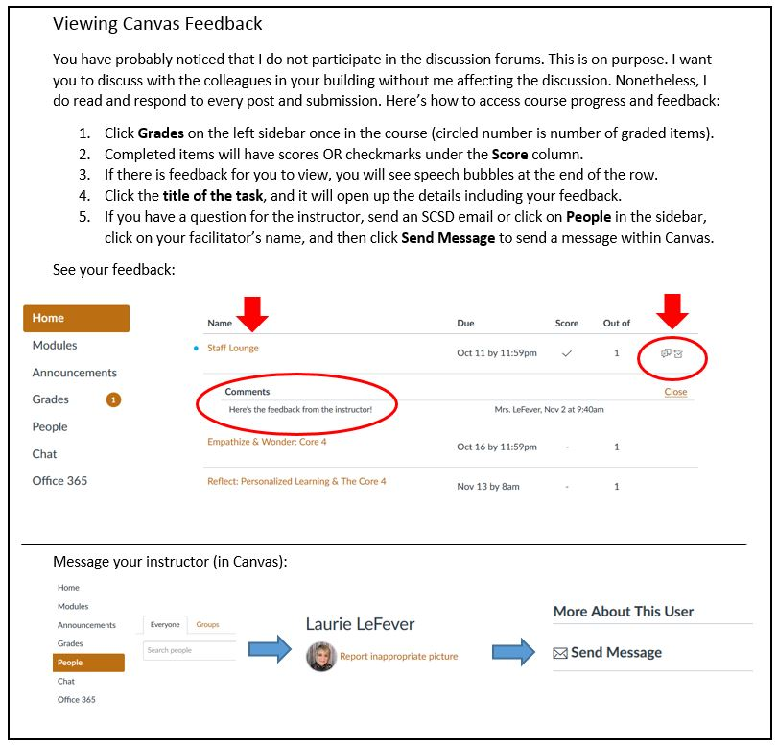If you have questions, reach out to your instructor via the contact information they shared with you.

2

3

1